**Statement of Work**

Digital Assets Delivery

***Lincoln U718***

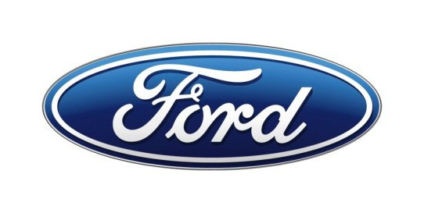

Ford Motor Company

Issued at Nov.12,2021

1. **Scope of Work**

Hardware Assumption : Two 23.6” L non-touch displays and a 11.1” L touch display.

Supplier will be responsible for full production HMI items below, features as specified in the feature list.

**Production HMI :**

* For up to 12 features which owned by HMI team, responsible for creating the function spec document based on input from Ford, and get sign-off from Ford.
* Provide innovative ideas in the interaction guideline design.
* Create and maintenance Interaction Guideline documents (based on initial version from Ford) and UE - kit in the whole design phase .
* Based on Ford team required, creating low to high-fidelity prototype or videos to demo HMI design to Ford broader teams in workshops or management reviews in the whole design phase.
* Complete UE (interaction spec) for full feature list provided by Ford, including all raw data files
  + Feature Interaction specifications & wireframes based on feature function specifications provided by Ford feature owner
  + Wireframes meet Ergo requirement for minimum font size, icon size, 1-finger reach, Rim & Stack block, etc.
  + All Interaction specs and wireframes need to be approved by Ford HMI, Feature owners
  + Quality assurance on all UE creation (If there’s any critical or a large number of quality issues which cause Ford spend much more time on reviewing and sign off, Ford will deduct DCR working hours of suppliers. )
* Complete UI (digital assets) including all raw data files for 4 visual themes * Day&Night mode for each theme
  + Create and/or Update Hero screens (Key pages) ’ design based on Ford design direction
  + Creating and maintaining the Visual Guide, UIkits and Icon library, need to approved by Ford HMI, Studio and Ergo
  + All UI assets created to match Hero screens in all themes approved by Ford
  + Font = Lincoln Madera ??
  + All assets need to be approved by Ford HMI, Feature owners, Studio and Ergo team
  + Assets should meet Ergo requirement as below :

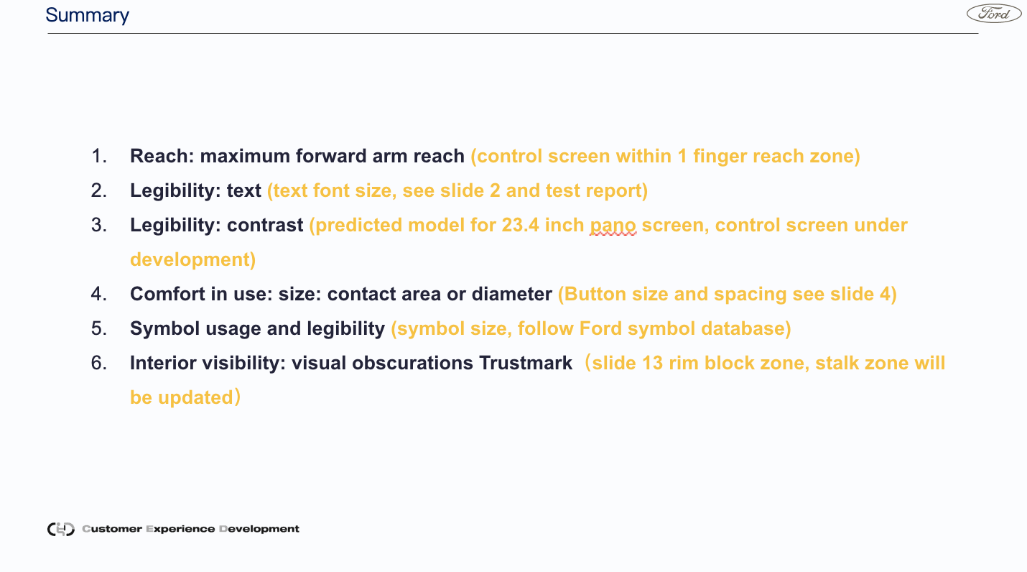

* Quality assurance on all UI creation (If there’s any critical or a large number of quality issues which cause Ford spend much more time on reviewing and sign off, Ford will deduct DCR working hours of suppliers. )
* Animations and motion graphics/transitions
  + Welcome & Farewell animations
  + Transitions
  + Micro animations
* Lead UE and UI design clarification and confirm feasibility to software team
* UE and UI validation to make sure software implementation is consistent with UE and UI signed off by Ford, follow up with software team on fix plan and report fix plan and fix status to Ford regularly.

**User Research :**

Supplier need to lead the user researches, coordination of prototype creating, script, site prepare, research host, participants hiring, and create reports based on request from Ford.

1. 2 rounds of User research on interaction guideline and key features HMI design

* Sample Size : 30 (confirm with Yanyan Cui)
* To create Low-fidelity interactive prototype development including interaction architecture and 10 key features for interaction architecture user research and Iterative Usability tests for new features if needed.
* Low-fidelity prototype for CDX707 hard buttons on the steering wheel and floor console
* Curved screen (provided by Ford) + 11.1 inch control screen (provided by supplier)
* Logistics for hardware shipping

2. Formal usability user test

* Sample Size : 36 ?? (confirm with Lulu)
* To create High fidelity Interactive prototype development including 30% pages of the product to meet program design review timeline and for usability testing.
* Purchase CDX707 hardware including pano screens and controllers
* Low-fidelity prototype for CDX707 hard buttons on the steering wheel and floor console
* Logistics for hardware shipping

**Project Management & Housekeeping :**

* Requires supplier PM and key designers on-site support in Ford Nanjing office for (1) Key management reviews and workshops (2) Monthly meeting
* All Ford global English interaction documents must be translated into Chinese by the vendor, and responsible for the translation correctness and readability.
* Collaboration with the global team, as needed, to support evening or early morning meetings
* All employees must be fluent in English and Chinese, reading, writing, verbal communication
* All work requires project management to track all delivery, signoff, and open issues
* All work requires launch support through Quality Assurance testing, design intent validation, UE/UI issue tracking, and resolution
* All work requires all specification documents be produced in English and Chinese
* All deliveries must include translation tables as needed for global teams
* Requires use of file formats and systems like Sketch, Jira, Invision
* All work requires collaboration with key ford stakeholders such as studio design, feature owners, ergonomics, etc.

1. **Timing**

HMI Delivery must support software delivery timelines for the program timing

Manage internal HMI delivery plan and timing, report to Ford in a regular period (Daily/Weekly/Bi-weekly/Monthly) as Ford required. Plan and timing need to be refined to each feature.

1. **Confidentiality**

All information shared by Ford and the supplier is classified as SECRET and shall obey the Global Information Management (GIM) disciplines defined by Ford Motor Company.

All data will be exchanged via a secure Internet connection (Ford OneDrive, Ford Sharepoint, etc.) approved by Ford Corporate Design and Ford IT Data Security.

1. **Reports and Metrics**

Reports of the project status must be generated on a weekly / fortnightly basis as required by Ford.

Company representatives must attend progress status meetings to report on development. Meetings are to be scheduled by Ford Motor Company, and may be held using secure HPRG/WebEx unless otherwise directed by Ford Motor Company.

1. **Team composition and quotation**

* Provide matched quantity and composition of the design team and research team according to the requirement of Ford.
* The ability of the lead designers and research teams needs to be reviewed by Ford HMI team and will be interviewed before kick off if necessary.

1. **Intellectual Property Ownership**

* The intellectual property of all interaction guideline, feature UE( interaction spec and wireframes) , UI (digital assets) , animations, low, mid and high fidelity prototypes, User research / test reports all belong to Ford Motor Company.